**MAKALAH**

**P EMROGRAMAN OPEN SOURCE**

**APLIKASI TIKET KERETA API**

Disusun untuk melengkapi tugas Mata Kuliah

Pemrograman Open Source

Dosen Pengajar : Ardymulya Iswardani, M.Kom



Disusun oleh :

**Murniyati (180101146)**

**PROGRAM STUDI SISTEM INFORMASI**

**FAKULTAS ILMU KOMPUTER**

**UNIVERSITAS DUTA BANGSA SURAKARTA**

* 1. MODUL LOG IN

Tampilan menu utama yang dipergunakan untuk log in sebagai berikut :

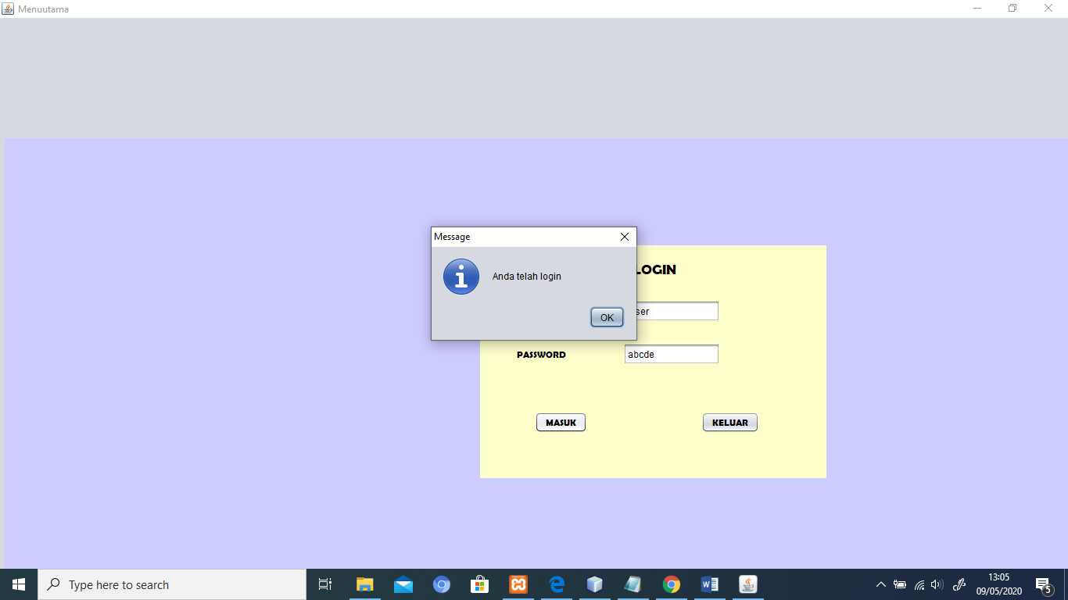

Gambar 1 Menu Log In

Keterangan :

Terdapat beberapa tombol pada meu log in ini yaitu :

* Tombol Username

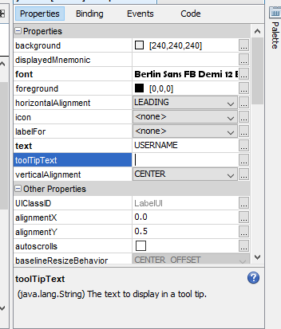

Penggunaan properties diantaranya :

Text kita isikan : USERNAME

Background & font : menyesuaikan  
Gambar 2. Properties tombol username

* 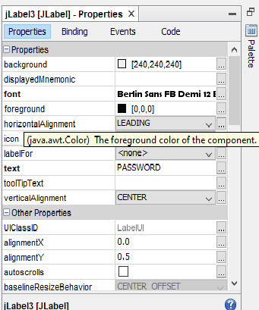Tombol Password

Penggunaan properties

Text kita isikan : PASSWORD

Background & font : menyesuaikan

Gambar 3. Properties password

Script codingnya sebagai berikut :

package tiketkereta;

import javax.swing.JOptionPane;

public class Menu_Utama extends javax.swing.JFrame {

/**

* Creates new form Menu_Utama

*/

public Menu_Utama() {

initComponents();

this.setExtendedState(Menu_Utama.MAXIMIZED_BOTH);

jMenuBar1.setVisible(false);

}

private void jButton1ActionPerformed(java.awt.event.ActionEvent evt) {

// TODO add your handling code here:

String user ="User";

String passw ="abcde";

if(user.equalsIgnoreCase(nama.getText()) && passw.equalsIgnoreCase(pass.getText()))

{JOptionPane.showMessageDialog(null, "Anda telah login");

jMenuBar1.setVisible(true);

this.jPanel1.setVisible(false);

nama.setText("");

pass.setText("");}

else{

javax.swing.JOptionPane.showMessageDialog(null, "Maaf user atau password Anda salah");

nama.setText("");

pass.setText("");

nama.requestFocus();

}

}

private void jButton2ActionPerformed(java.awt.event.ActionEvent evt) {

// TODO add your handling code here:

if(JOptionPane.showConfirmDialog(null, "Yakin ingin keluar?"

+ "\n jika iya tekan OK","Information", JOptionPane.OK_CANCEL_OPTION,JOptionPane.INFORMATION_MESSAGE)==JOptionPane.OK_OPTION){

try{

this.dispose();

}catch(Exception e){

JOptionPane.showMessageDialog(null, e.getMessage());

}

}

}

private void jMenuItem1ActionPerformed(java.awt.event.ActionEvent evt) {

// TODO add your handling code here:

new datatiket().show();

}

private void jMenuItem2ActionPerformed(java.awt.event.ActionEvent evt) {

// TODO add your handling code here:

new datapemesan().show();

}

private void jMenuItem7ActionPerformed(java.awt.event.ActionEvent evt) {

// TODO add your handling code here:

new datakereta().show();

}

private void jMenuItem8ActionPerformed(java.awt.event.ActionEvent evt) {

// TODO add your handling code here:

new datapetugas().show();

}

private void jMenuItem3ActionPerformed(java.awt.event.ActionEvent evt) {

// TODO add your handling code here:

new pemesanantiket().show();

}

private void jMenuItem4ActionPerformed(java.awt.event.ActionEvent evt) {

// TODO add your handling code here:

}

private void jMenuItem5ActionPerformed(java.awt.event.ActionEvent evt) {

// TODO add your handling code here:

int pesan=JOptionPane.showConfirmDialog(null, "Yakin ?","Konfirmasi",JOptionPane.YES_NO_OPTION

,JOptionPane.QUESTION_MESSAGE);

if (pesan==JOptionPane.YES_OPTION){

jMenuBar1.setVisible(false); this.jPanel1.setVisible(true);

}

}

Selanjutnya setelah berhasil log in, kita akan masuk pada tampilan menu utama yang terdiri dari 3 item yaitu FILE, TRANSAKSI, dan LAPORAN

Item FILE terdiri dari 4 tabel yaitu :

* DATA TIKET
* DATA PEMESAN
* DATA KERETA
* DATA PETUGAS

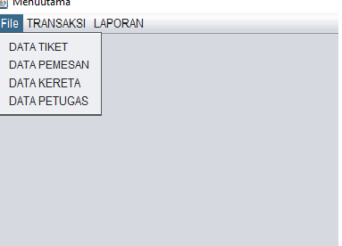 Gambar 4 Item File pada Menu Utama

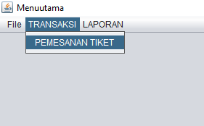

Item TRANSAKSI berisi tabel pemesanan tiket

Gambar 5 Item Transaksi pada Menu Utama

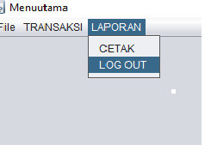Item LAPORAN berisi pilihan CETAK dan Log Out

Gambar 5 Item Laporan pada Menu Utama

* 1. MODUL CRUD (CREATE READ UPDATE DELETE)
     1. DATA KERETA API

Tampilan tabelnya sebagai berikut

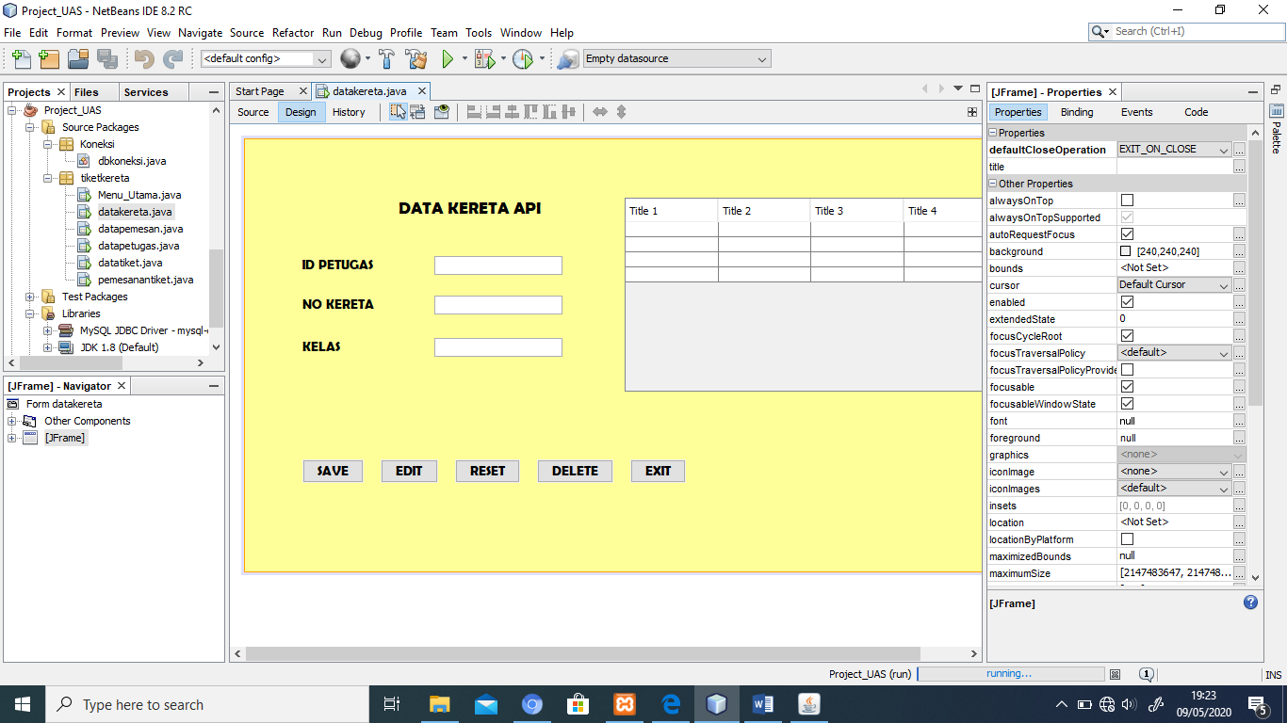

Gambar 6. Tampilan Tabel Kereta Api

Keterangan :

Judul table “DATA KERETA API”

ID PETUGAS, NO KERETA, KELAS

Tombol yang tersedia : SAVE, EDIT, RESET, DELETE, EXIT

Adapun source codenya sebagai berikut

package tiketkereta;

import Koneksi.dbkoneksi;

import com.mysql.jdbc.Statement;

import java.sql.PreparedStatement;

import java.sql.ResultSet;

import java.sql.SQLException;

import javax.swing.JOptionPane;

import javax.swing.table.DefaultTableModel;

public final class datakereta extends javax.swing.JFrame {

private DefaultTableModel model;

String id, no;

int kelas;

public void getData() {

// Mengahpus isi table siswa

model.getDataVector().removeAllElements();

model.fireTableDataChanged();

try{

// membuat statement pemanggilan data pada table

Statement stat = (Statement) dbkoneksi.getKoneksi().createStatement();

String sql= "Select * from tblkereta";

ResultSet res = stat.executeQuery(sql)

//penelusuran baris pada tabel

while(res.next()){

Object[] obj = new Object[8];

obj[0] = res.getString("ID_Petugas");

obj[1] = res.getString("No_Kereta");

obj[2] = res.getString("Kelas");

model.addRow(obj);

}

}catch(SQLException err){

JOptionPane.showConfirmDialog(null, err.getMessage());

}

}

public datakereta() {

initComponents();

model = new DefaultTableModel();

tblkereta.setModel(model);

model.addColumn("ID Petugas");

model.addColumn("No Kereta");

model.addColumn("Kelas");

getData();

}

public void loadData(){

id = txtidpetugas.getText();

no = txtno.getText();

kelas = Integer.parseInt(txtkelas.getText());

}

public void saveData(){

loadData();

try{

Statement stat = (Statement) dbkoneksi.getKoneksi().createStatement();

String sql = "Insert into tblkereta (ID_Petugas,No_Kereta,Kelas)"

+ "values ('"+ id +"','"+ no +"','"+ kelas +"')";

PreparedStatement p = (PreparedStatement) dbkoneksi.getKoneksi().prepareStatement(sql);

p.executeUpdate();

getData();

}catch(SQLException err){

JOptionPane.showMessageDialog(null, err.getMessage());

}

}

public void Reset(){

id ="";

no ="";

kelas =0;

txtidpetugas.setText(id);

txtno.setText(no);

txtkelas.setText("");

}

public void dataSelect(){

int i = tblkereta.getSelectedRow();

if (i == -1){

return;

}

txtidpetugas.setText(""+model.getValueAt(i, 0));

txtno.setText(""+model.getValueAt(i, 1));

txtkelas.setText(""+model.getValueAt(i, 2));

}

public void editData(){

loadData();

try{

Statement stat = (Statement) dbkoneksi.getKoneksi().createStatement();

String sql = "UPDATE tblkereta SET No_Kereta = '"+ no +"',"

+ "Kelas = '"+ kelas +"' WHERE ID_Petugas= '"+ id +"'";

PreparedStatement p = (PreparedStatement) dbkoneksi.getKoneksi().prepareStatement(sql);

p.executeUpdate();

getData();

Reset();

JOptionPane.showMessageDialog(null, "Edit berhasil....");

}catch(SQLException er){

JOptionPane.showMessageDialog(null, er.getMessage());

}

}

public void hapusData(){

loadData();

int pesan = JOptionPane.showConfirmDialog(null, "Anda yakin Menghapus data : "+ id +"?","Konfirmasi",

JOptionPane.OK_CANCEL_OPTION);

if (pesan == JOptionPane.OK_OPTION){

try{

Statement stat = (Statement) dbkoneksi.getKoneksi().createStatement();

String sql = "DELETE FROM tblkereta WHERE ID_Petugas= '"+ id +"'";

PreparedStatement p = (PreparedStatement) dbkoneksi.getKoneksi().prepareStatement(sql);

p.executeUpdate();

getData();

Reset();

JOptionPane.showMessageDialog(null, "Data berhasil dihapus");

}catch(SQLException er){

JOptionPane.showMessageDialog(null, er.getMessage());

}

}

}

private void btnsaveActionPerformed(java.awt.event.ActionEvent evt) {

// TODO add your handling code here:

saveData();

}

private void btneditActionPerformed(java.awt.event.ActionEvent evt) {

// TODO add your handling code here:

editData();

}

private void btnresetActionPerformed(java.awt.event.ActionEvent evt) {

// TODO add your handling code here:

Reset();

}

private void btndeleteActionPerformed(java.awt.event.ActionEvent evt) {

// TODO add your handling code here:

hapusData();

}

private void btnexitActionPerformed(java.awt.event.ActionEvent evt) {

// TODO add your handling code here:

this.dispose();

}

private void tblkeretaMouseClicked(java.awt.event.MouseEvent evt) {

// TODO add your handling code here:

dataSelect();

Berikut tampilan table setelah dijalankan

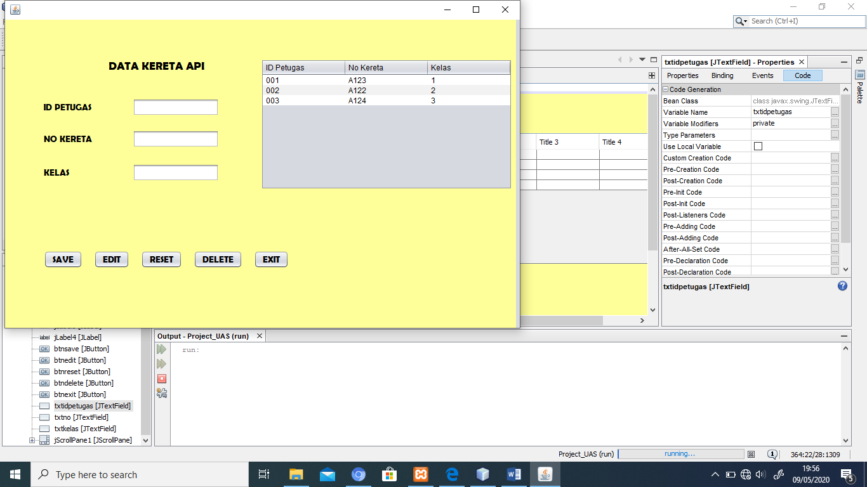

Gambar 7. Tampilan table kereta api

* + 1. DATA TIKET

Berikut tampilan tabel data tiket

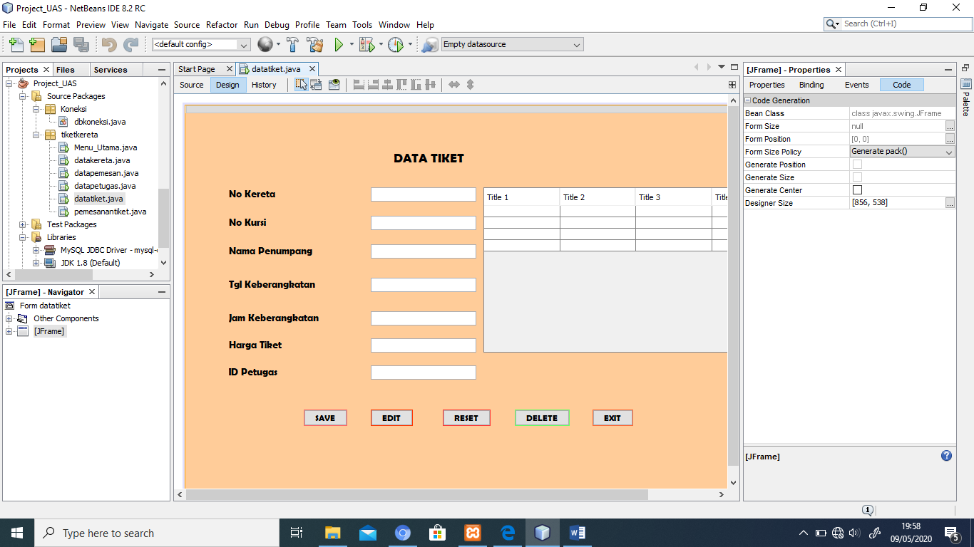

Gambar 8. Table data tiket

Terdiri dari Judul ‘DATA TIKET”

No Kereta, No Kursi, Nama Penumpang, Tgl Keberangkatan, Jam Keberangkatan, Harga tiket, ID Petugas

Tombol yang tersedia : SAVE, EDIT, RESET, DELETE, EXIT

Adapun source codenya sebagai berikut

package tiketkereta;

import Koneksi.dbkoneksi;

import com.mysql.jdbc.Statement;

import java.sql.PreparedStatement;

import java.sql.ResultSet;

import java.sql.SQLException;

import javax.swing.JOptionPane;

import javax.swing.table.DefaultTableModel;

public final class datatiket extends javax.swing.JFrame {

private DefaultTableModel model;

String no, kursi, nama, tgl, jam, harga, id;

public void getData() {

// Mengahpus isi table

model.getDataVector().removeAllElements();

model.fireTableDataChanged();

try{

// membuat statement pemanggilan data pada table

Statement stat = (Statement) dbkoneksi.getKoneksi().createStatement();

String sql= "Select * from tbltiket";

ResultSet res = stat.executeQuery(sql);

//penelusuran baris pada tabel

while(res.next()){

Object[] obj = new Object[7];

obj[0] = res.getString("No_Kereta");

obj[1] = res.getString("No_Kursi");

obj[2] = res.getString("Nama_Penumpang");

obj[3] = res.getString("Tgl_Keberangkatan");

obj[4] = res.getString("Jam_keberangkatan");

obj[5] = res.getString("Harga_Tiket");

obj[6] = res.getString("ID_Petugas");

model.addRow(obj);

}

}catch(SQLException err){

JOptionPane.showConfirmDialog(null, err.getMessage());

}

}

public datatiket() {

initComponents();

model = new DefaultTableModel();

tbltiket.setModel(model);

model.addColumn("No Kereta");

model.addColumn("No Kursi");

model.addColumn("Nama Penumpang");

model.addColumn("Tgl Keberangkatan");

model.addColumn("Jam Keberangkatan");

model.addColumn("Harga Tiket");

model.addColumn("ID Petugas");

getData();

}

public void loadData(){

no = txtno.getText();

kursi = txtkursi.getText();

nama = txtnama.getText();

tgl = txttgl.getText();

jam = txtjam.getText();

harga = txtharga.getText();

id = txtid.getText();

}

public void saveData(){

loadData();

try{

Statement stat = (Statement) dbkoneksi.getKoneksi().createStatement();

String sql = "Insert into tbltiket (No_Kereta, No_Kursi, Nama_Penumpang, Tgl_Keberangkatan, Jam_Keberangkatan, Harga_Tiket, ID_Petugas)"

+ "values ('"+ no +"','"+ kursi +"','"+ nama +"','"+ tgl +"','"+ jam +"','"+ harga +"','"+ id +"')";

PreparedStatement p = (PreparedStatement) dbkoneksi.getKoneksi().prepareStatement(sql);

p.executeUpdate();

getData();

}catch(SQLException err){

JOptionPane.showMessageDialog(null, err.getMessage());

}

}

public void Reset(){

no ="";

kursi ="";

nama ="";

tgl ="";

jam ="";

harga ="";

id ="";

txtno.setText(no);

txtkursi.setText(kursi);

txtnama.setText(nama);

txttgl.setText(tgl);

txtjam.setText(jam);

txtharga.setText(harga);

txtid.setText(id);

}

public void dataSelect(){

int i = tbltiket.getSelectedRow();

if (i == -1){

return;

}

txtno.setText(""+model.getValueAt(i, 0));

txtkursi.setText(""+model.getValueAt(i, 1));

txtnama.setText(""+model.getValueAt(i, 2));

txttgl.setText(""+model.getValueAt(i, 3));

txtjam.setText(""+model.getValueAt(i, 4));

txtharga.setText(""+model.getValueAt(i, 5));

txtid.setText(""+model.getValueAt(i, 6));

}

public void editData(){

loadData();

try{

Statement stat = (Statement) dbkoneksi.getKoneksi().createStatement();

String sql = "UPDATE tbltiket SET No_Kursi = '"+ kursi +"',"

+ "Nama_Penumpang = '"+ nama +"',"

+ "Tgl_Keberangkatan = '"+ tgl +"',"

+ "Jam_Keberangkatan = '"+ jam +"',"

+ "Harga_Tiket = '"+ harga +"',"

+ "ID_Petugas = '"+ id +"' WHERE No_Kereta = '"+ no +"'";

PreparedStatement p = (PreparedStatement) dbkoneksi.getKoneksi().prepareStatement(sql);

p.executeUpdate();

getData();

Reset();

JOptionPane.showMessageDialog(null, "Edit berhasil....");

}catch(SQLException er){

JOptionPane.showMessageDialog(null, er.getMessage());

}

}

public void hapusData(){

loadData();

int pesan = JOptionPane.showConfirmDialog(null, "Anda yakin Menghapus data : "+ no +"?","Konfirmasi",

JOptionPane.OK_CANCEL_OPTION);

if (pesan == JOptionPane.OK_OPTION){

try{

Statement stat = (Statement) dbkoneksi.getKoneksi().createStatement();

String sql = "DELETE FROM tbltiket WHERE No_Kereta = '"+ no +"'";

PreparedStatement p = (PreparedStatement) dbkoneksi.getKoneksi().prepareStatement(sql);

p.executeUpdate();

getData();

Reset();

JOptionPane.showMessageDialog(null, "Data berhasil dihapus");

}catch(SQLException er){

JOptionPane.showMessageDialog(null, er.getMessage());

}

}

}

private void btnEditActionPerformed(java.awt.event.ActionEvent evt) {

// TODO add your handling code here:

editData();

}

private void btnResetActionPerformed(java.awt.event.ActionEvent evt) {

// TODO add your handling code here:

Reset();

}

private void btnSaveActionPerformed(java.awt.event.ActionEvent evt) {

// TODO add your handling code here:

saveData();

}

private void btndeleteActionPerformed(java.awt.event.ActionEvent evt) {

// TODO add your handling code here:

hapusData();

}

private void btnexitActionPerformed(java.awt.event.ActionEvent evt) {

// TODO add your handling code here:

this.dispose();

}

private void tbltiketMouseClicked(java.awt.event.MouseEvent evt) {

// TODO add your handling code here:

dataSelect();

}

public static void main(String args[]) {

java.awt.EventQueue.invokeLater(new Runnable() {

public void run() {

new datatiket().setVisible(true);

}

});

}

Tampilan table setelah dijalankan sebagai berikut

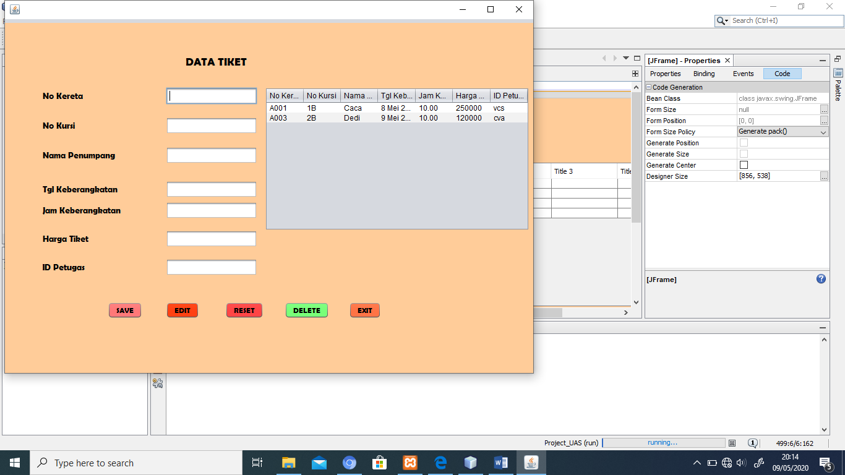

Gambar 9. Tampilan table data tiket

* + 1. TABEL PETUGAS

Berikut tampilan table petugas

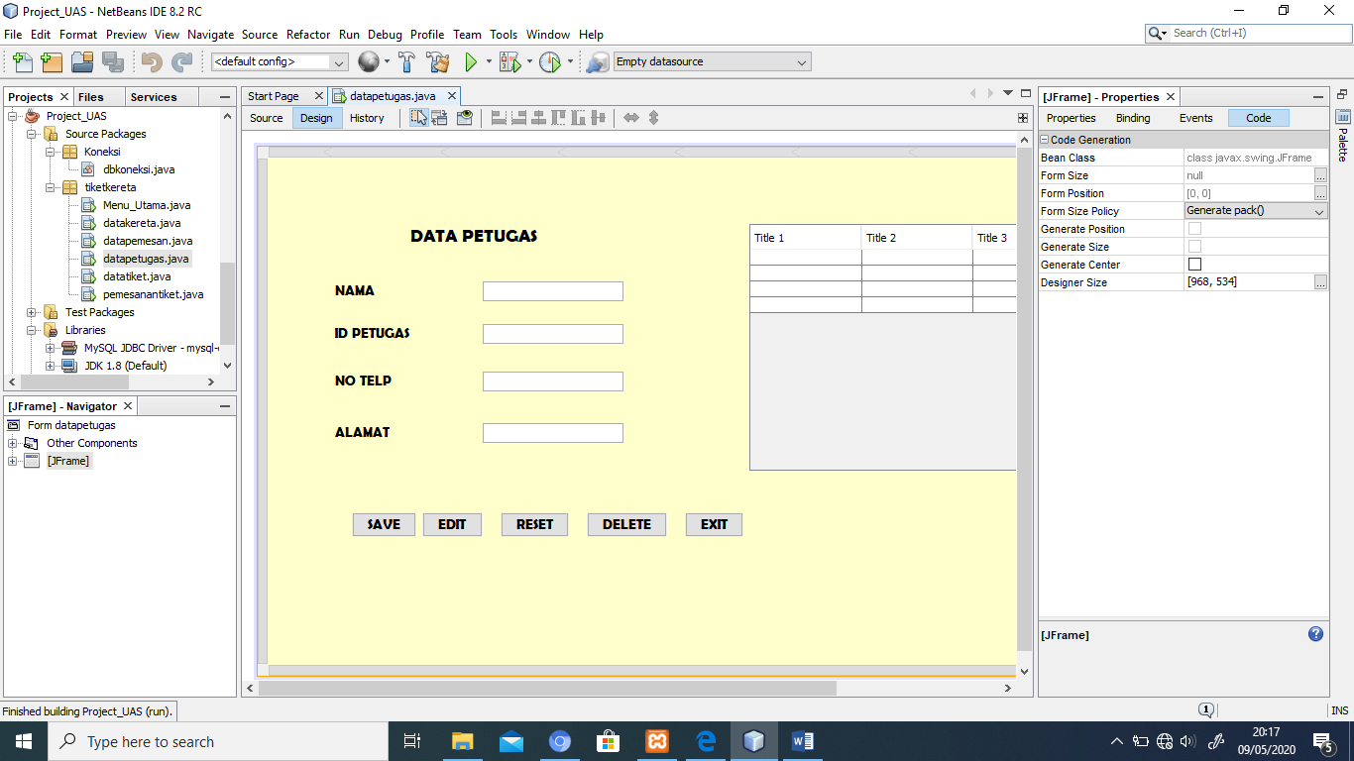

Gambar 10. Tabel Petugas

Tabel petugas berisi

Judul “DATA PETUGAS”, nama, ID Petugas, No. Telp, Alamat

Tombol yang tersedia : SAVE, EDIT, RESET, DELETE, EXIT

Adapun source codenya sebagai berikut :

package tiketkereta;

import Koneksi.dbkoneksi;

import com.mysql.jdbc.Statement;

import java.sql.PreparedStatement;

import java.sql.ResultSet;

import java.sql.SQLException;

import javax.swing.JOptionPane;

import javax.swing.table.DefaultTableModel;

public final class datapetugas extends javax.swing.JFrame {

private DefaultTableModel model;

String nama, id, telp, alamat;

public void getData() {

// Mengahpus isi table datapetugas

model.getDataVector().removeAllElements();

model.fireTableDataChanged();

try{

// membuat statement pemanggilan data pada table

Statement stat = (Statement) dbkoneksi.getKoneksi().createStatement();

String sql= "Select * from tblpetugas";

ResultSet res = stat.executeQuery(sql);

//penelusuran baris pada tabel

while(res.next()){

Object[] obj = new Object[4];

obj[0] = res.getString("Nama_Petugas");

obj[1] = res.getString("ID_Petugas");

obj[2] = res.getString("No_Telp");

obj[3] = res.getString("Alamat");

model.addRow(obj);

}

}catch(SQLException err){

JOptionPane.showConfirmDialog(null, err.getMessage());

}

}

public datapetugas() {

initComponents();

model = new DefaultTableModel();

tblpetugas.setModel(model);

model.addColumn("Nama_Petugas");

model.addColumn("ID_Petugas");

model.addColumn("No_Telp");

model.addColumn("Alamat");

getData();

}

public void loadData(){

nama = txtnama.getText();

id = txtid.getText();

telp = txttelp.getText();

alamat = txtalamat.getText();

}

public void saveData(){

loadData();

try{

Statement stat = (Statement) dbkoneksi.getKoneksi().createStatement();

String sql = "Insert into tblpetugas (Nama_Petugas,ID_Petugas,No_Telp,Alamat)"

+ "values ('"+ nama +"','"+ id +"','"+ telp +"','"+ alamat +"')";

PreparedStatement p = (PreparedStatement) dbkoneksi.getKoneksi().prepareStatement(sql);

p.executeUpdate();

getData();

}catch(SQLException err){

JOptionPane.showMessageDialog(null, err.getMessage());

}

}

public void Reset(){

nama ="";

id ="";

telp ="";

alamat ="";

txtnama.setText(nama);

txtid.setText(id);

txttelp.setText(telp);

txtalamat.setText(alamat);

}

public void dataSelect(){

int i = tblpetugas.getSelectedRow();

if (i == -1){

return;

}

txtnama.setText(""+model.getValueAt(i, 0));

txtid.setText(""+model.getValueAt(i, 1));

txttelp.setText(""+model.getValueAt(i, 2));

txtalamat.setText(""+model.getValueAt(i, 3));

}

public void editData(){

loadData();

try{

Statement stat = (Statement) dbkoneksi.getKoneksi().createStatement();

String sql = "UPDATE tblpetugas SET ID_petugas = '"+ id +"',"

+ "No_Telp = '"+ telp +"',"

+ "Alamat = '"+ alamat +"' WHERE Nama_Petugas = '"+ nama +"'";

PreparedStatement p = (PreparedStatement) dbkoneksi.getKoneksi().prepareStatement(sql);

p.executeUpdate();

getData();

Reset();

JOptionPane.showMessageDialog(null, "Edit berhasil....");

}catch(SQLException er){

JOptionPane.showMessageDialog(null, er.getMessage());

}

}

public void hapusData(){

loadData();

int pesan = JOptionPane.showConfirmDialog(null, "Anda yakin Menghapus data : "+ nama +"?","Konfirmasi",

JOptionPane.OK_CANCEL_OPTION);

if (pesan == JOptionPane.OK_OPTION){

try{

Statement stat = (Statement) dbkoneksi.getKoneksi().createStatement();

String sql = "DELETE FROM tblpetugas WHERE Nama_Petugas= '"+ nama +"'";

PreparedStatement p = (PreparedStatement) dbkoneksi.getKoneksi().prepareStatement(sql);

p.executeUpdate();

getData();

Reset();

JOptionPane.showMessageDialog(null, "Data berhasil dihapus");

}catch(SQLException er){

JOptionPane.showMessageDialog(null, er.getMessage());

}

}

}

private void btnsaveActionPerformed(java.awt.event.ActionEvent evt) {

// TODO add your handling code here:

saveData();

}

private void btneditActionPerformed(java.awt.event.ActionEvent evt) {

// TODO add your handling code here:

editData();

}

private void btnresetActionPerformed(java.awt.event.ActionEvent evt) {

// TODO add your handling code here:

Reset();

}

private void jButton4ActionPerformed(java.awt.event.ActionEvent evt) {

// TODO add your handling code here:

hapusData();

}

private void btnexitActionPerformed(java.awt.event.ActionEvent evt) {

// TODO add your handling code here:

this.dispose();

}

Tampilan table petugas setelah dijalankan sebagai berikut

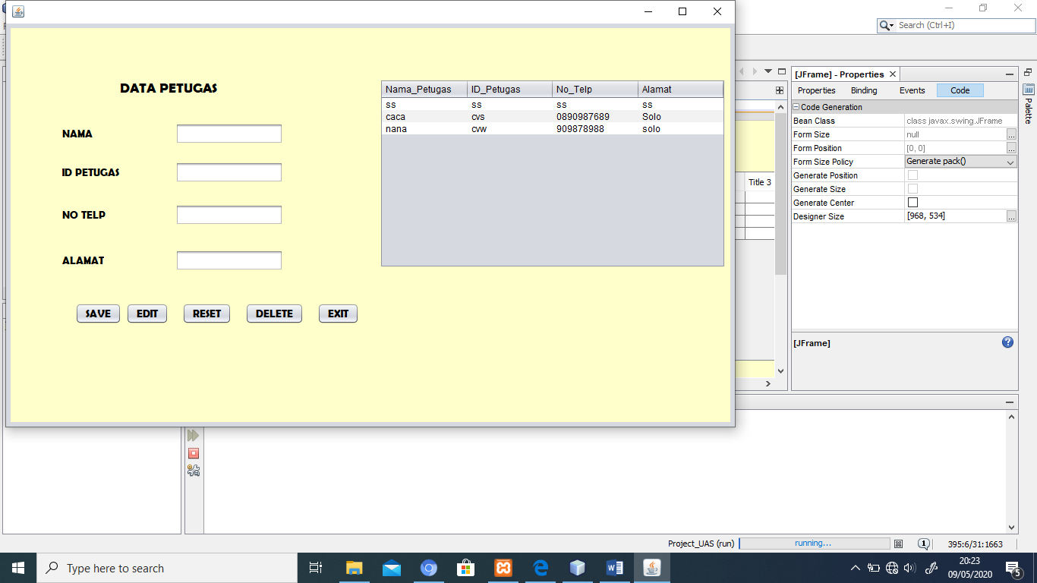

Gambar 11. Tabel petugas

* + 1. TABEL PEMESAN

Berikut tampilan table pemesan

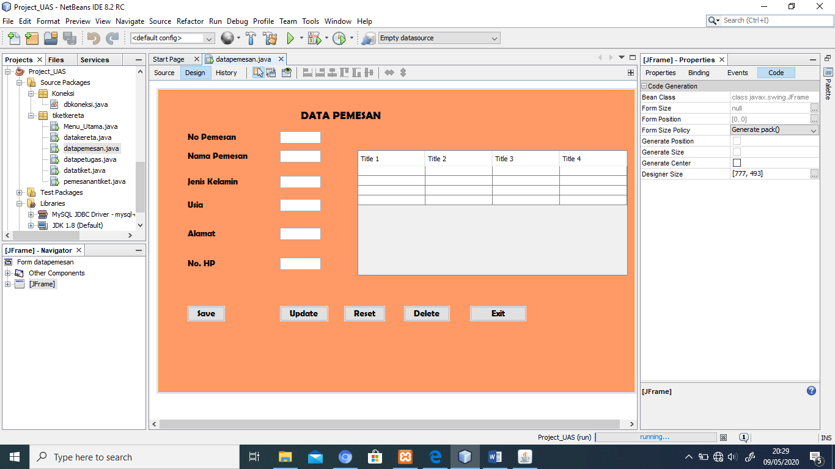

Gambar 12. Tabel pemesan

Terdiri dari judul “Data Pemesan”, No pemesan, Nama Pemesan, Jenis Kelamin, Usia, Alamat, No. HP

Tombol yang tersedia : SAVE, EDIT, RESET, DELETE, EXIT

Adapun source codenya sebagai berikut

package tiketkereta;

import Koneksi.dbkoneksi;

import com.mysql.jdbc.Statement;

import java.sql.PreparedStatement;

import java.sql.ResultSet;

import java.sql.SQLException;

import javax.swing.JOptionPane;

import javax.swing.table.DefaultTableModel;

public final class datapemesan extends javax.swing.JFrame {

private DefaultTableModel model;

String no,nama, jenkel, usia, alamat, nohp;

public void getData() {

// Mengahpus isi table siswa

model.getDataVector().removeAllElements();

model.fireTableDataChanged();

try{

// membuat statement pemanggilan data pada table

Statement stat = (Statement) dbkoneksi.getKoneksi().createStatement();

String sql= "Select * from tblpemesan";

ResultSet res = stat.executeQuery(sql);

//penelusuran baris pada tabel

while(res.next()){

Object[] obj = new Object[8];

obj[0] = res.getString("No_Pemesan");

obj[1] = res.getString("Nama_Pemesan");

obj[2] = res.getString("Jenis_Kelamin");

obj[3] = res.getString("Usia");

obj[4] = res.getString("Alamat");

obj[5] = res.getString("No_HP");

model.addRow(obj);

}

}catch(SQLException err){

JOptionPane.showConfirmDialog(null, err.getMessage());

}

}

public datapemesan() {

initComponents();

model = new DefaultTableModel();

tblpemesan.setModel(model);

model.addColumn("No Pemesan");

model.addColumn("Nama Pemesan");

model.addColumn("Jenis Kelamin");

model.addColumn("Usia");

model.addColumn("Alamat");

model.addColumn("No. HP");

getData();

}

public void loadData(){

no = txtno.getText();

nama = txtnama.getText();

jenkel = txtjenkel.getText();

usia = txtusia.getText();

alamat = txtalamat.getText();

nohp = txtnohp.getText();

}

public void saveData(){

loadData();

try{

Statement stat = (Statement) dbkoneksi.getKoneksi().createStatement();

String sql = "Insert into tblpemesan (No_Pemesan,Nama_Pemesan,Jenis_Kelamin,Usia,Alamat,No_HP)"

+ "values ('"+ no +"','"+ nama +"','"+ jenkel +"','"+ usia +"','"+ alamat +"','"+ nohp +"')";

PreparedStatement p = (PreparedStatement) dbkoneksi.getKoneksi().prepareStatement(sql);

p.executeUpdate();

getData();

}catch(SQLException err){

JOptionPane.showMessageDialog(null, err.getMessage());

}

}

public void Reset(){

no ="";

nama ="";

jenkel ="";

usia ="";

alamat ="";

nohp ="";

txtno.setText(no);

txtnama.setText(nama);

txtjenkel.setText(jenkel);

txtusia.setText(usia);

txtalamat.setText(alamat);

txtnohp.setText(nohp);

}

public void dataSelect(){

int i = tblpemesan.getSelectedRow();

if (i == -1){

return;

}

txtno.setText(""+model.getValueAt(i, 0));

txtnama.setText(""+model.getValueAt(i, 1));

txtjenkel.setText(""+model.getValueAt(i, 2));

txtusia.setText(""+model.getValueAt(i, 3));

txtalamat.setText(""+model.getValueAt(i, 4));

txtnohp.setText(""+model.getValueAt(i, 5));

}

public void editData(){

loadData();

try{

Statement stat = (Statement) dbkoneksi.getKoneksi().createStatement();

String sql = "UPDATE tblpemesan SET Nama_Pemesan = '"+ nama +"',"

+ "Jenis_Kelamin = '"+ jenkel +"',"

+ "Usia = '"+ usia +"',"

+ "Alamat = '"+ alamat +"',"

+ "No_Hp = '"+ nohp +"' WHERE No_Pemesan = '"+ no +"'";

PreparedStatement p = (PreparedStatement) dbkoneksi.getKoneksi().prepareStatement(sql);

p.executeUpdate();

getData();

Reset();

JOptionPane.showMessageDialog(null, "Edit berhasil....");

}catch(SQLException er){

JOptionPane.showMessageDialog(null, er.getMessage());

}

}

public void hapusData(){

loadData();

int pesan = JOptionPane.showConfirmDialog(null, "Anda yakin Menghapus data : "+ no +"?","Konfirmasi",

JOptionPane.OK_CANCEL_OPTION);

if (pesan == JOptionPane.OK_OPTION){

try{

Statement stat = (Statement) dbkoneksi.getKoneksi().createStatement();

String sql = "DELETE FROM tblpemesan WHERE No_Pemesan= '"+ no +"'";

PreparedStatement p = (PreparedStatement) dbkoneksi.getKoneksi().prepareStatement(sql);

p.executeUpdate();

getData();

Reset();

JOptionPane.showMessageDialog(null, "Data berhasil dihapus");

}catch(SQLException er){

JOptionPane.showMessageDialog(null, er.getMessage());

}

}

}

rivate void btnsaveActionPerformed(java.awt.event.ActionEvent evt) {

// TODO add your handling code here:

saveData();

}

private void btnupdateActionPerformed(java.awt.event.ActionEvent evt) {

// TODO add your handling code here:

editData();

}

private void btnresetActionPerformed(java.awt.event.ActionEvent evt) {

// TODO add your handling code here:

Reset();

}

private void btndeleteActionPerformed(java.awt.event.ActionEvent evt) {

// TODO add your handling code here:

hapusData();

}

private void btnexitActionPerformed(java.awt.event.ActionEvent evt) {

// TODO add your handling code here:

this.dispose();

}

private void tblpemesanMouseClicked(java.awt.event.MouseEvent evt) {

// TODO add your handling code here:

dataSelect();

Tampilan table pemesan setelah dijalankan sebagai berikut

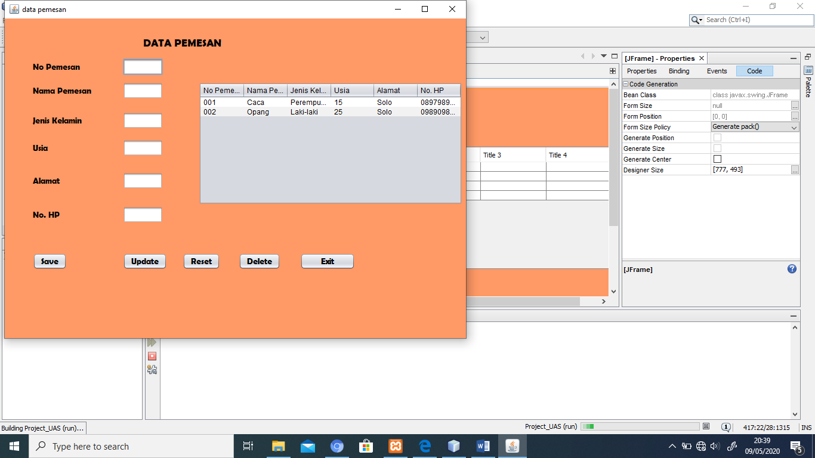

Gambar 13. Tabel Pemesan

* 1. MODUL TRANSAKSI

Tabel transaksi pemesanan tiket sebagai berikut

Pet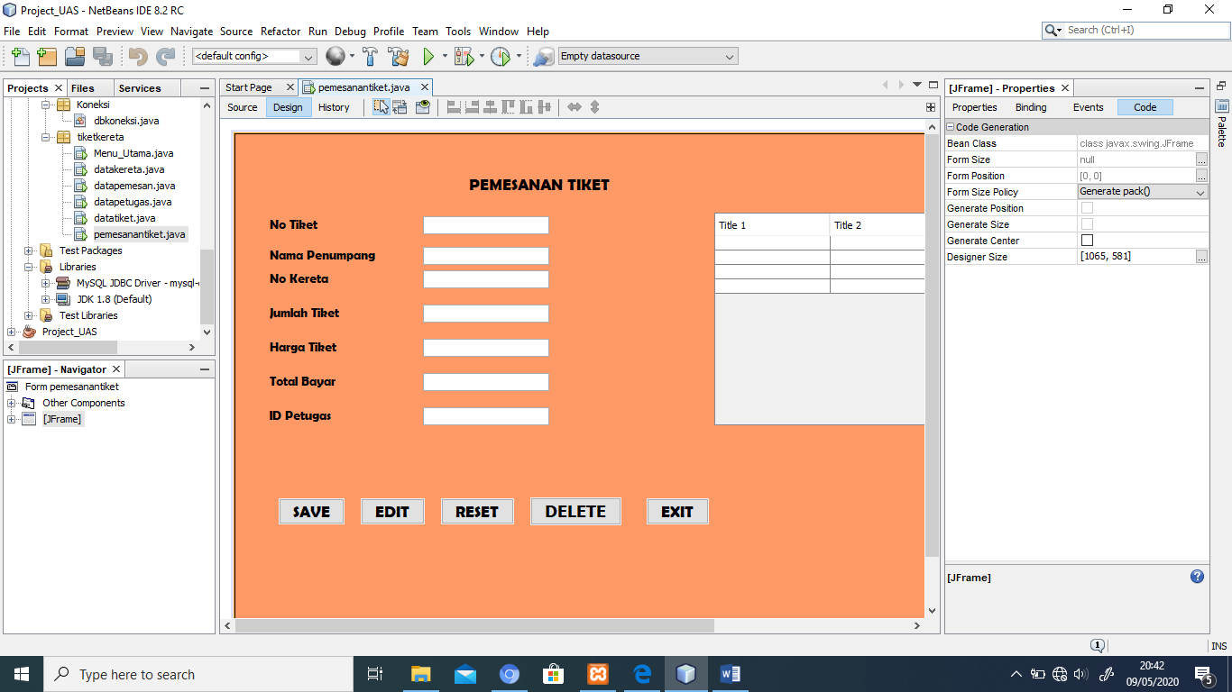

Gambar 14. Tabel transaksi pemesanan tiket

Terdiri dari judul “PEMESANAN TIKET”, No. Tiket, Nama Penumpang, No Kereta, Jumlah tiket, harga Tiket, total bayar, ID Petugas.

Tombol yang tersedia : SAVE, EDIT, RESET, DELETE, EXIT

Adapun source codenya sebagai berikut

package tiketkereta;

import Koneksi.dbkoneksi;

import com.mysql.jdbc.Statement;

import java.sql.PreparedStatement;

import java.sql.ResultSet;

import java.sql.SQLException;

import javax.swing.JOptionPane;

import javax.swing.table.DefaultTableModel;

public final class pemesanantiket extends javax.swing.JFrame {

private DefaultTableModel model;

String tiket,nama, no, jml, hrg, bayar, id;

public void getData() {

// Mengahpus isi table siswa

model.getDataVector().removeAllElements();

model.fireTableDataChanged();

try{

// membuat statement pemanggilan data pada table

Statement stat = (Statement) dbkoneksi.getKoneksi().createStatement();

String sql= "Select * from tbltransaksitiket";

ResultSet res = stat.executeQuery(sql);

//penelusuran baris pada tabel

while(res.next()){

Object[] obj = new Object[8];

obj[0] = res.getString("No_Tiket");

obj[1] = res.getString("Nama_Penumpang");

obj[2] = res.getString("No_Kereta");

obj[3] = res.getString("Jumlah_Tiket");

obj[4] = res.getString("Harga_Tiket");

obj[5] = res.getString("Total_Bayar");

obj[6] = res.getString("ID_Petugas");

model.addRow(obj);

}

}catch(SQLException err){

JOptionPane.showConfirmDialog(null, err.getMessage());

}

}

public pemesanantiket() {

initComponents();

model = new DefaultTableModel();

tbltransaksitiket.setModel(model);

model.addColumn("No Tiket");

model.addColumn("Nama Penumpang");

model.addColumn("No Kereta");

model.addColumn("Jumlah Tiket");

model.addColumn("Harga Tiket");

model.addColumn("Total Bayar");

model.addColumn("ID Petugas");

getData();

}

public void loadData(){

tiket = txttiket.getText();

nama = txtnama.getText();

no = txtno.getText();

jml = txtjml.getText();

hrg = txthrg.getText();

bayar = txtbayar.getText();

id = txtid.getText();

}

public void saveData(){

loadData();

try{

Statement stat = (Statement) dbkoneksi.getKoneksi().createStatement();

String sql = "Insert into tbltransaksitiket (No_Tiket,Nama_Penumpang,No_Kereta,Jumlah_Tiket,Harga_Tiket,Total_Bayar,ID_Petugas)"

+ "values ('"+ tiket +"','"+ nama +"','"+ no +"','"+ jml +"','"+ hrg +"','"+ bayar +"','"+ id +"')";

PreparedStatement p = (PreparedStatement) dbkoneksi.getKoneksi().prepareStatement(sql);

p.executeUpdate();

getData();

}catch(SQLException err){

JOptionPane.showMessageDialog(null, err.getMessage());

}

}

public void Reset(){

tiket ="";

nama ="";

no ="";

jml ="";

hrg ="";

bayar ="";

id ="";

txttiket.setText(tiket);

txtnama.setText(nama);

txtno.setText(no);

txtjml.setText(jml);

txthrg.setText(hrg);

txtbayar.setText(bayar);

txtid.setText(id);

}

public void dataSelect(){

int i = tbltransaksitiket.getSelectedRow();

if (i == -1){

return;

}

txttiket.setText(""+model.getValueAt(i, 0));

txtnama.setText(""+model.getValueAt(i, 1));

txtno.setText(""+model.getValueAt(i, 2));

txtjml.setText(""+model.getValueAt(i, 3));

txthrg.setText(""+model.getValueAt(i, 4));

txtbayar.setText(""+model.getValueAt(i, 5));

txtid.setText(""+model.getValueAt(i, 6));

}

public void editData(){

loadData();

try{

Statement stat = (Statement) dbkoneksi.getKoneksi().createStatement();

String sql = "UPDATE tbltransaksitiket SET Nama_Penumpang = '"+ nama +"',"

+ "No_Kereta = '"+ no +"',"

+ "Jumlah_Tiket = '"+ jml +"',"

+ "Harga_Tiket = '"+ hrg +"',"

+ "Total_Bayar = '"+ bayar +"',"

+ "ID_Petugas = '"+ id +"' WHERE No_Tiket = '"+ tiket +"'";

PreparedStatement p = (PreparedStatement) dbkoneksi.getKoneksi().prepareStatement(sql);

p.executeUpdate();

getData();

Reset();

JOptionPane.showMessageDialog(null, "Edit berhasil....");

}catch(SQLException er){

JOptionPane.showMessageDialog(null, er.getMessage());

}

}

public void hapusData(){

loadData();

int pesan = JOptionPane.showConfirmDialog(null, "Anda yakin Menghapus data : "+ no +"?","Konfirmasi",

JOptionPane.OK_CANCEL_OPTION);

if (pesan == JOptionPane.OK_OPTION){

try{

Statement stat = (Statement) dbkoneksi.getKoneksi().createStatement();

String sql = "DELETE FROM tbltransaksitiket WHERE No_Tiket = '"+ tiket +"'";

PreparedStatement p = (PreparedStatement) dbkoneksi.getKoneksi().prepareStatement(sql);

p.executeUpdate();

getData();

Reset();

JOptionPane.showMessageDialog(null, "Data berhasil dihapus");

}catch(SQLException er){

JOptionPane.showMessageDialog(null, er.getMessage());

}

}

}

private void btnsaveActionPerformed(java.awt.event.ActionEvent evt) {

// TODO add your handling code here:

saveData();

}

private void btneditActionPerformed(java.awt.event.ActionEvent evt) {

// TODO add your handling code here:

editData();

}

private void btnresetActionPerformed(java.awt.event.ActionEvent evt) {

// TODO add your handling code here:

Reset();

}

private void btndeleteActionPerformed(java.awt.event.ActionEvent evt) {

// TODO add your handling code here:

hapusData();

}

private void btnexitActionPerformed(java.awt.event.ActionEvent evt) {

// TODO add your handling code here:

this.dispose();

}

private void tbltransaksitiketMouseClicked(java.awt.event.MouseEvent evt) {

// TODO add your handling code here:

dataSelect();

}

Tampilan tabel transaksi pemesanan setelah dijalankan sebagai berikut

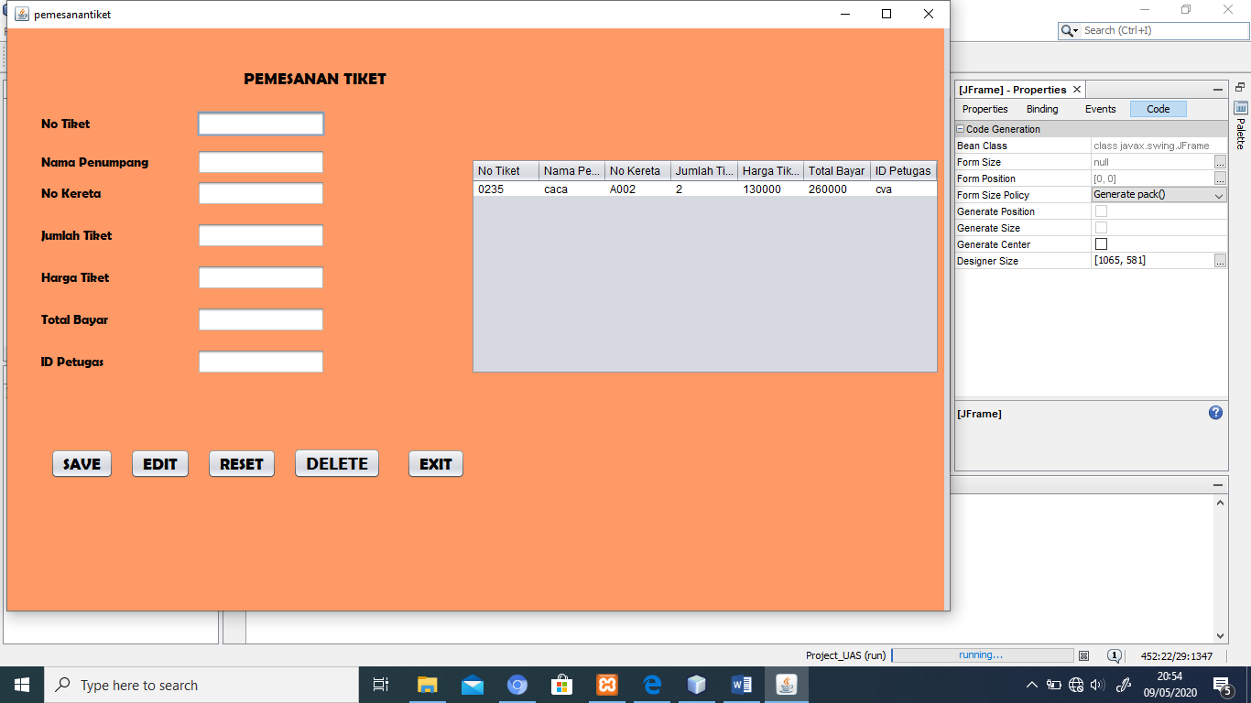

Gambar 15. Tampilan table pemesanan tiket